100 AI Interview Questions and Answers



**Anish Mahapatra**

Contents

Introduction 3

Q. What is the Gartner Hype Cycle? 3

Structure of the blog 4

**Part A: Topic-Based Questions** 4

1 MLOps / AIOps 4

2 RPA 4

3 Ethical AI 4

4 AI Cloud Service 4

5 AI Governance 4

6 RPA – Robotic Process Automation 4

7 Scalable AI 4

8 XAI / Explainable AI 5

9 Cyber Security AI 5

10 AutoML 5

**Part-B: Scenario-Based Questions** 5

1 Real World AI 5

2 Mainstream Computer Vision 5

3 Federated Learning 5

4 Enterprise-Grade AI Solutions 5

5 Future of AI 5

# Introduction

With so many pseudo-data scientists cropping up due to numerous courses that offer theoretical learning, the questions in interviews is getting streamlined to filter those that understand how real-world implementation works. It is important to understand how data flows in the real world and what sort of questions are being discussed across companies.

**The value of a company lies solely in the interview process.**

Interviews across companies are growing to appreciate those that have an end-to-end understanding of how problems can be dealt with over theoretical understanding. This detailed blog is dedicated to help you understand the latest trends in the industry and how you can absorb them. Everything you will need to know for an interview will be detailed out here. We will start off with by understanding what the trends in artificial intelligence are.

## Q. What is the Gartner Hype Cycle?

Gartner is a market leader in market research. The Gartner Hype Cycle Methodology is an industry-approved representation of how a technology or application will mature over time. It represents initial interest, a peak in its hype, rolls down to reduced interest in the technology followed by maturity and implementation. A lot of demand in the market comes through in two points in this cycle, in the peak and the maturity. That’s where most of the money can be made from a corporate job.

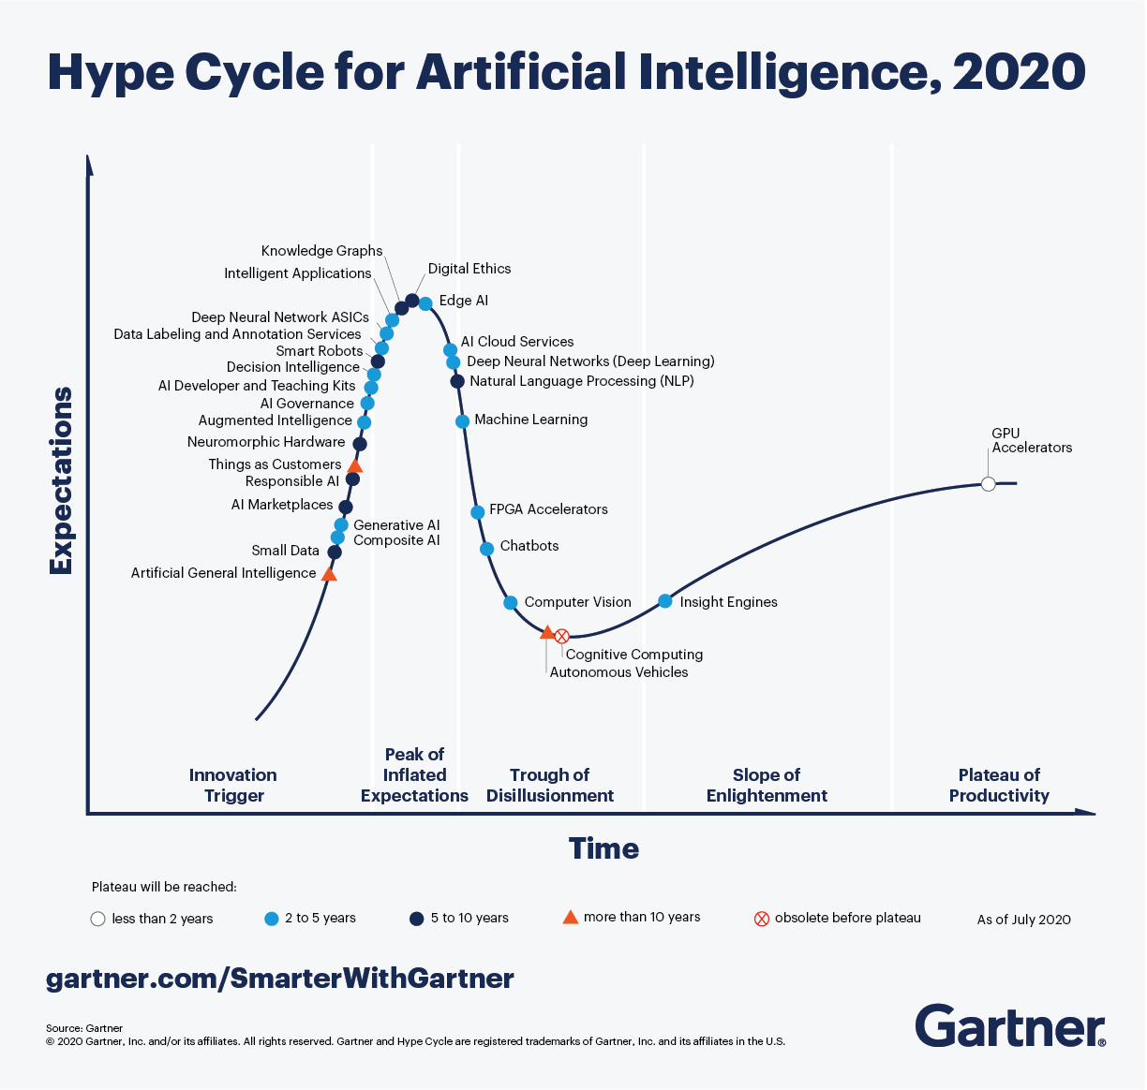

Looking at the Hype Cycle for artificial intelligence, focusing on the **blue** dots in the cycle, those are topics that are of interest in the next two to five years. An understanding of various innovation triggers in the space of artificial intelligence will help elevate conversation and make you stand out in the eyes of the interviewer. The answer is never to simply answer the question, but add an additional layer of context that will stick.

This blog will not tell you exactly how to answer questions when asked. It will explain what an instace of the best-in-class answes would sound like. We will try to use as many visual aids and examples to answer so that you can apply it in multiple scenarios and interviews.

# Structure of the blog

A lot of thought was put in as to what would make most sense in terms of structure when putting forth 100 AI interview questions and answers. For the first 50 questions, we will go over 5 questions each for 10 topics followed by 50 scenario-based questions. In the first section, we will try and cover as many current and future proof topics that we have seen being asked in some of the best analytics companies.

# **Part A: Topic-Based Questions**

# 1 AutoML

A

# 2 MLOps / AIOps

A

# 3 AI Cloud Service

A

# 4 Scalable AI

A

# 5 AI Governance

A

# 6 XAI / Explainable AI

A

# 7 Ethical AI

A

# 8 Cyber Security AI

A

# 9 RPA: Robotic Process Automation

A

# 10 GANs” Generative Adversarial Networks

A

# **Part-B: Scenario-Based Questions**

# 1 Real World AI

A

# 2 Mainstream Computer Vision

A

# 3 Federated Learning

A

# 4 Enterprise-Grade AI Solutions

A

# 5 Future of AI

A